**1. Read a CSV file with data in multiple columns and compute mean, median mode of each of the columns.**

import pandas as pd

from statistics import median, mode, StatisticsError

df = pd.read_csv('/content/drive/MyDrive/Task1 - Sheet1.csv')

print("Original DataFrame:")

print(df.to_string(index=False))

results = []

for subject in df.columns[1:]:

col_mean = df[subject].mean()

col_median = median(df[subject])

try:

col_mode = mode(df[subject])

except StatisticsError:

col_mode = "N/A"

results.append((subject, col_mean, col_median, col_mode))

results_df = pd.DataFrame(results, columns=['Subject', 'Mean', 'Median', 'Mode'])

print("\nCalculated Statistics:")

print(results_df.to_string(index=False))

**Output:-**

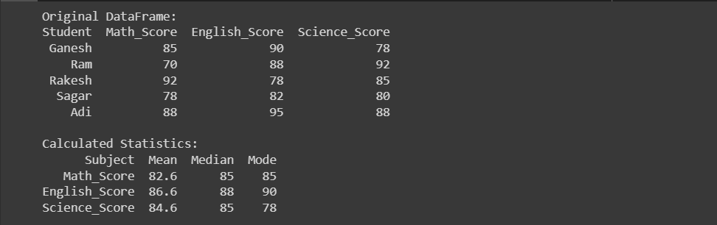

**2. Plot each of the columns with different colors (check what kind of graph is suitable)**

import pandas as pd

import matplotlib.pyplot as plt

data = {

'Student': ['Ganesh', 'Ram', 'Rakesh', 'Sagar', 'Adi'],

'Math_Score': [85, 70, 92, 78, 88],

'English_Score': [90, 88, 78, 82, 95],

'Science_Score': [78, 92, 85, 80, 88]

}

df = pd.DataFrame(data)

df.set_index('Student', inplace=True)

ax = df.plot(kind='bar', figsize=(10, 6))

ax.set_ylabel('Scores')

ax.set_xlabel('Students')

ax.set_title('Student Scores')

plt.tight_layout()

plt.show()

**Output:-**

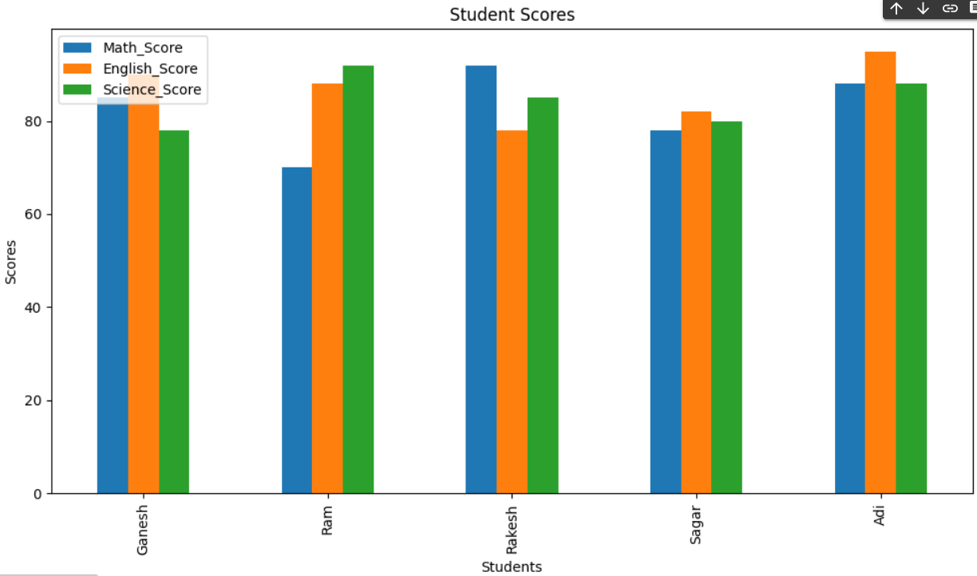

**3. Create a game (like lottery/ rock paper/scissors) and write a python code to record how many times the computer won and the user won in an excel file. Plot the graph showing the success rate of user and computer with different colors.**

import random

import pandas as pd

import matplotlib.pyplot as plt

def coin_flip():

return random.choice(["Heads", "Tails"])

def plot_success_rates(user_wins, computer_wins):

total_games = user_wins + computer_wins

user_success_rate = (user_wins / total_games) * 100

computer_success_rate = (computer_wins / total_games) * 100

success_rates = pd.DataFrame({

'Success Rate': [user_success_rate, computer_success_rate],

'Player': ['User', 'Computer']

})

success_rates.plot(kind='bar', x='Player', y='Success Rate', color=['blue', 'green'])

plt.ylabel('Success Rate (%)')

plt.title('Success Rate Comparison')

plt.ylim(0, 100)

plt.show()

user_wins = 0

computer_wins = 0

game_results = []

while True:

print("Welcome to the Coin Flip Game!")

user_guess = input("Enter your guess (Heads/Tails): ").capitalize()

flip_result = coin_flip()

print(f"The coin landed on {flip_result}.")

winner = "User" if user_guess == flip_result else "Computer"

if winner == "User":

print("Congratulations! You guessed it right!")

user_wins += 1

else:

print( You guessed it wrong. Computer wins.")

computer_wins += 1

game_results.append({'User Wins': user_wins, 'Computer Wins': computer_wins})

pd.DataFrame(game_results).to_excel('game_outcomes.xlsx', index=False)

play_again = input("Do you want to play again? (yes/no): ").lower()

if play_again != "yes":

break

plot_success_rates(user_wins, computer_wins)

**Output:-**

